**Community**

1. Profile
2. Home
3. Registrations
4. Schedules
5. Peoples
   1. Users
   2. Priests
   3. Presenters
   4. Hosts
6. Locations
7. Reports
   1. Liabilities
   2. Monthly Income
   3. 2020 Weekends
   4. Upcoming Weekends
8. Finance
   1. Receipts
   2. Donations
   3. Scholarships
   4. Payment Method
9. Enrichments
10. Community Resources
11. More
    1. Settings
    2. Features
    3. Special Invitations
    4. Deleted Registrations
    5. Expense Details
    6. Parishes

**Profile**

This is a user profile page where users can edit and update their information from this page.

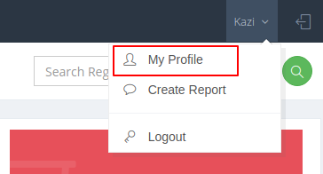

**Home**

This is a community landing page or home page. 9 different important features and page showing in this page.

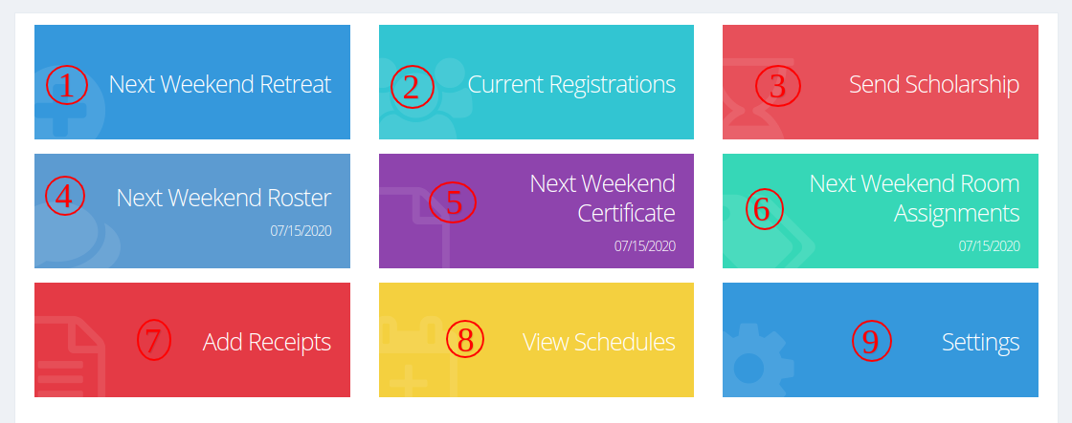

1. **Next Weekend Retreat:**

Here click to redirect next weekend's retreats page.

1. **Current Registrations:**

Here click to redirect registrations list page.

1. **Send Scholarship:**

Here click to show a scholarship sending pop up for send scholarship.

1. **Next Weekend Roster:**

Here click and show next weekend roster pdf.

1. **Next Weekend Certificate:**

Here click to show wedding completion certificate pdf for next weekend.

1. **Next Weekend Room Assignments:**

Room assignment pdf show when click on this.

1. **Add Receipts:**

Here click to redirect receipt creation page.

1. **View Schedules:**

Here click to redirect weekend list page.

1. **Settings:**

Here click to open community settings page.

**Registration**

**There are 4 type of registration in this system:**

1. Manual Registration
2. Special Invite Registration
3. Scholarship Registration
4. Plugin Registration

**Schedule**

This is the Weekend/schedule list page here all weekend shows on this page.

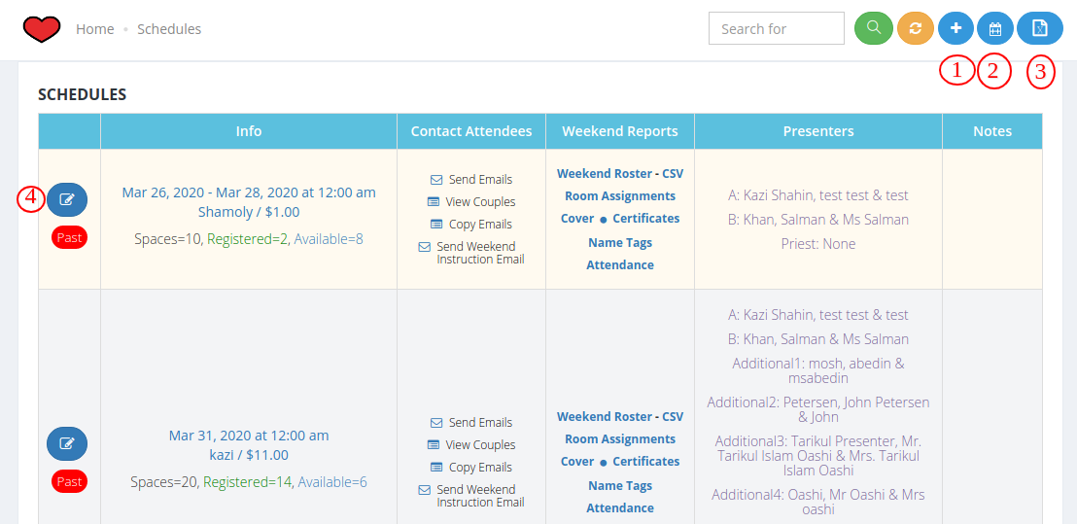

1. **Create Schedule:** Create schedule with all weekend information. Max capacity, retreat start date, venue, price are mandatory fields for creating a new schedule.

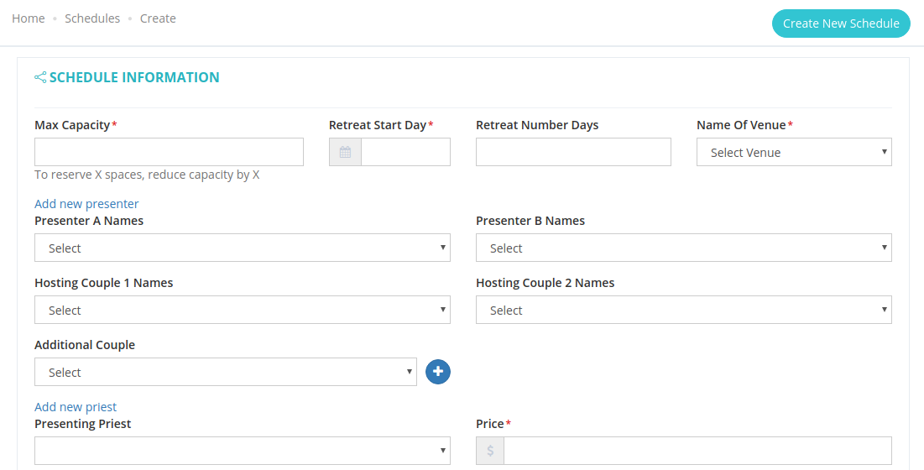

1. **Create Multiple Schedule:** Admin can create multiple schedules with same location and multiple retreat date.

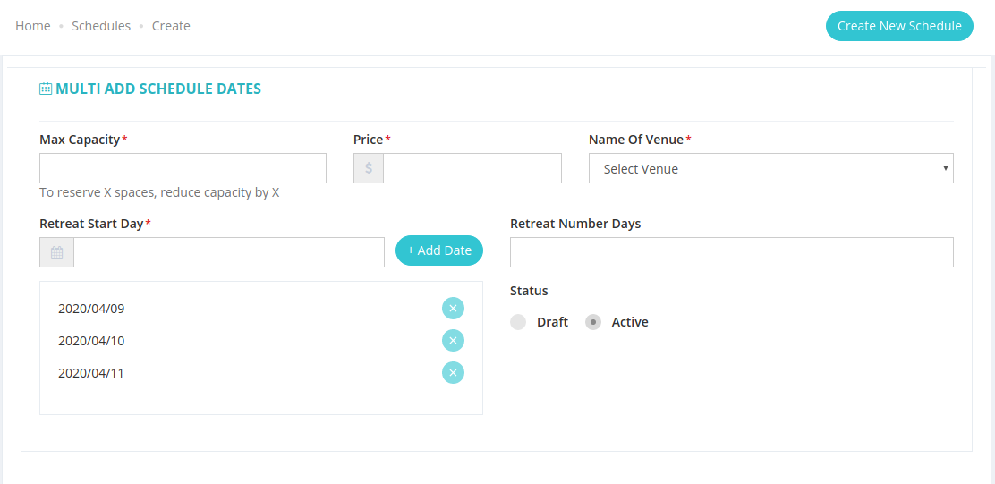

1. **Current view to excel:** This button opens an excel file with all weekend information for this community.
2. **Edit Schedule:**
   1. Admin can edit schedule information by this edit option.
   2. Admin can’t update past schedule.

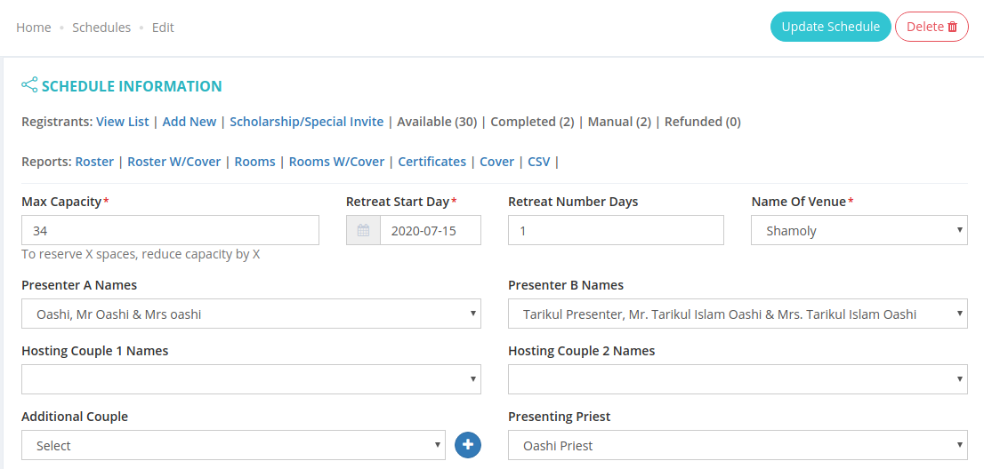

* 1. **Registrants List:** In the edit schedule page all registered couples show here.

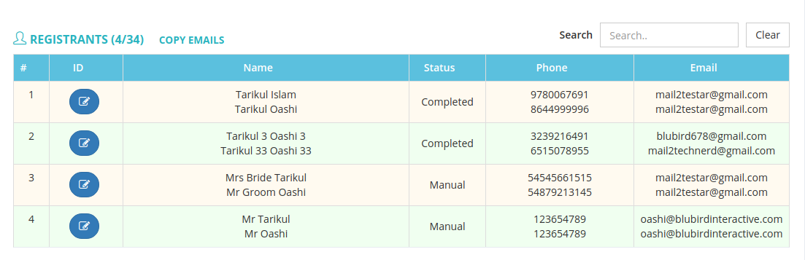

**Peoples - User**

1. User List: community all users showing in this page.this user access only for this community.

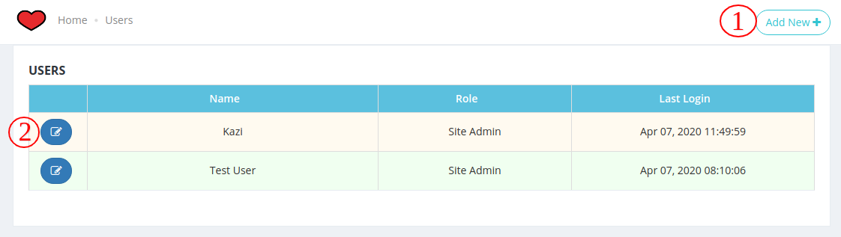

1. **Create User:** this is create a user page here name, email, role and password field are mandatory.

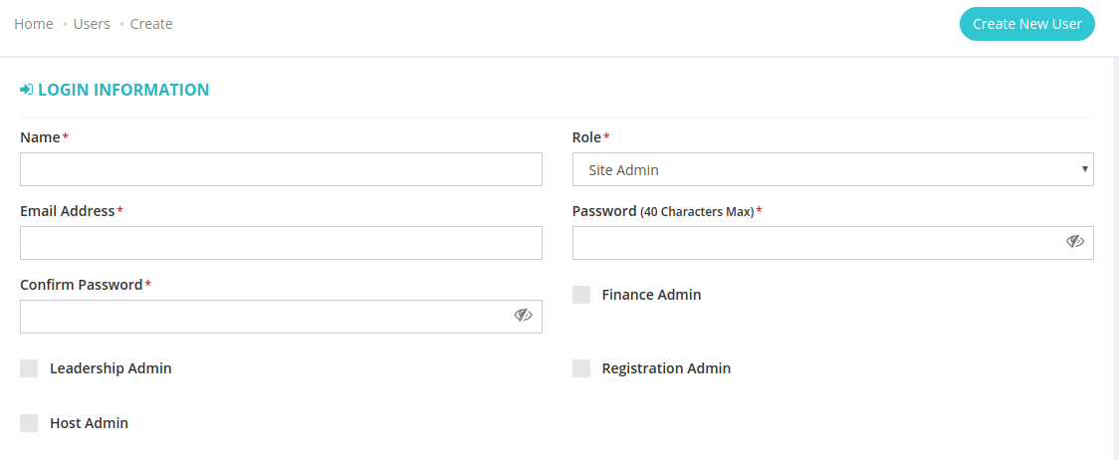

1. **Edit user:** User information can edit on this page.

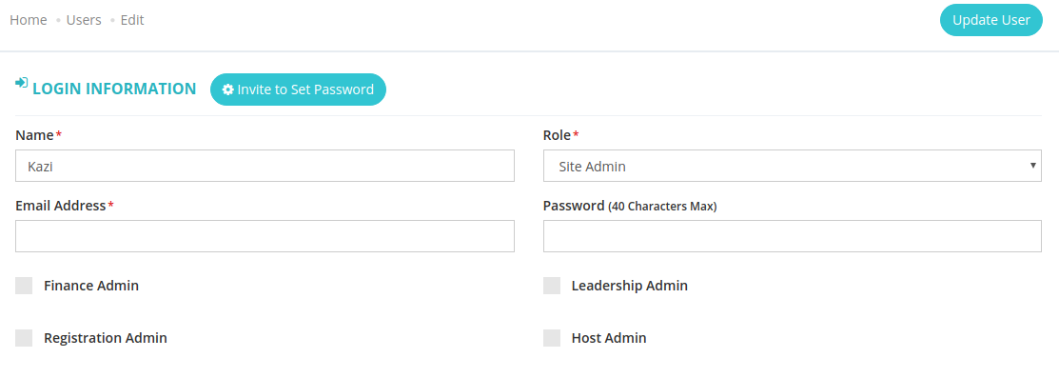

**Peoples - Priests**

**Priests List:**

Community all priests showing in this page with their contact information.

1. **Download Priest PDF:**

Community all priests information can download as pdf in this button.

1. **Copy Email:**

Copy to all priests' email in this button.

1. **Create/Edit Priests:**

create/Edit priests with their all information name is mandatory and other not mandatory fields.

**Peoples - Presenter**

Presenter is who can present the weekend retreats. All presenters shown on this page for this community.Presenter family names, husband and wife names, email and phone are shown on this page.

1. **Downloads Presenters(PDF):**

In this PDF showing all presenters husband and wife name, email, phone, image, home address.

1. **Copy Email:**

In this feature, copy all the presenter(husband and wife) email.

1. **Edit/Update Presenter:**

Presenter information can edit or update in this feature.

**Peoples - Host**

Host is who can host the weekend retreats.Host’s family names, husband and wife names, email and phone are shown on this page.

1. **Downloads Presenters(PDF):**

In this PDF showing all hosts husband and wife name, email, phone, image, home address.

1. **Copy Email:**

In this feature copy all Host(husband and wife) email.

1. **Edit/Update Host:**

Host’s information can be edited or updated in this feature.

**Location**

Community all locations showing in this page. Weekend retreat programs use this location for weddings. Admin can create these locations with name, Details address, price, check in time, google map.

**Reports**

1. **Liabilities:**

This page shows the total number of couples which are registered for future weekend, weekend location and total amount per weekend. Total registered amount for all weekend.

1. **Income:**

This page shows the community all registration income.

1. **Current Year Weekends PDF:**

This pdf shows the current year all weekends, locations, presenters and priests.

1. **Upcoming Weekends PDF:**

This PDF shows upcoming weeknds for this community.

**Finance**

1. **Receipts:**

If needed, weekend wise receipts can be created on this page.

1. **Donations:**

All donations information shown in this page with IPN information.

1. **Scholarships:**

Here to send scholarships registration link. All scholarships request showing in this page. Admin can complete any registration request and after complete this registration status showing as manual.

1. **Payment Method:**

This page shows all payment methods which are used in this community.

**Enrichments**

Here showing all enrichment email templates and enrichment sending settings options. Here to set any enrichment mail sent to couples Before/After Weekends and Before/After weeding.Here also has a checking option who gets this mail.

**More - Settings**

1. Community name settings.
2. Contact person name, phone settings.
3. System time zone settings.
4. System language settings.
5. Payment settings.
6. **SMTP Settings For:**
   1. Google API.
   2. Gmail.
   3. Outlook.
   4. Office365.
   5. Other
7. Default Certificate showing setting.
8. Default Name Tag showing setting.
9. **Email Template:**
   1. **Scholarship Offer Email:**

This email received by couples when he/she gets a scholarship offer.

* 1. **Scholarship Request To Priest/Parish Email:**

When any couples register then priests get this email.

* 1. **Link To Approve Scholarship Email:**

This email received by priests with approval live. Priests check registered information and priests can accept/decline.

* 1. **Scholarship Approval Email To Couples:**

This email received by couples when priests accept scholarships.

* 1. **Scholarship Denial Email To Couples:**

This email received by couples when priests decline scholarships.

* 1. **Scholarship Approval Notice To Registration User:**

This email received by priests for approving Registration.

* 1. **Confirmation Letter Message:**

This email received couples and who do payment after payment completion.

* 1. **Refund Letter Message:**

This email received couples and payment email when refunded any payment.

* 1. **Weekend Instructions:**

This email received couples when the community admin set which day’s before get this mail.

* 1. **Weekend Cover Page Text:**

This template text showing weekend cover inside pdf.

**More**

1. **Features:**

Here showing all new features with details.

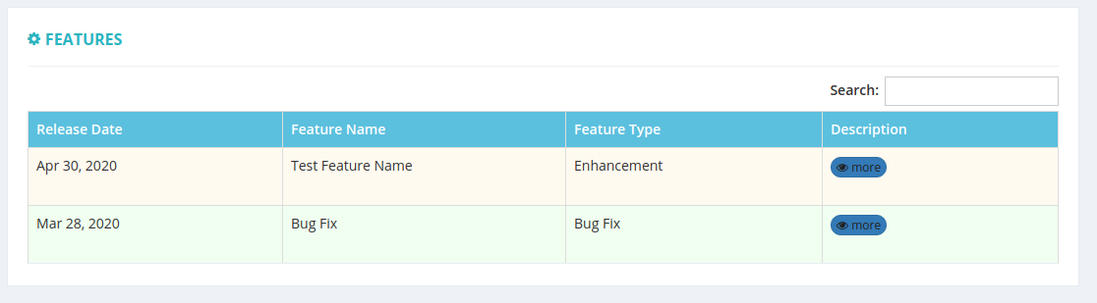

1. **Special Invitations:**

All special invitations are listed on this page. Who gets the special invitation from which weekend that is listed on this page. Admin can send a special invitation on this page.

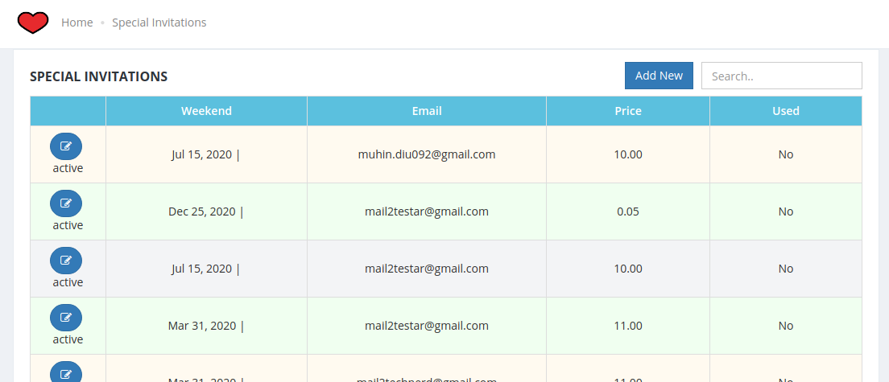

1. **Delete Registrations:**

Here showing all deleted registration admin undeleted any registration via Undeleted button.

1. **Expense Details:**

Community all expenses showing in this page.

1. **Parishes:**

Community all parish locations showing in this page. Admin can create any parish and can update parishes information.